**Working with VPN:**

1.Choose a reputable free VPN service and sign up.

**Proton VPN free tier**

2.Download and insta l the VPN client.

3.Connect to a VPN server (choose closest or any location).

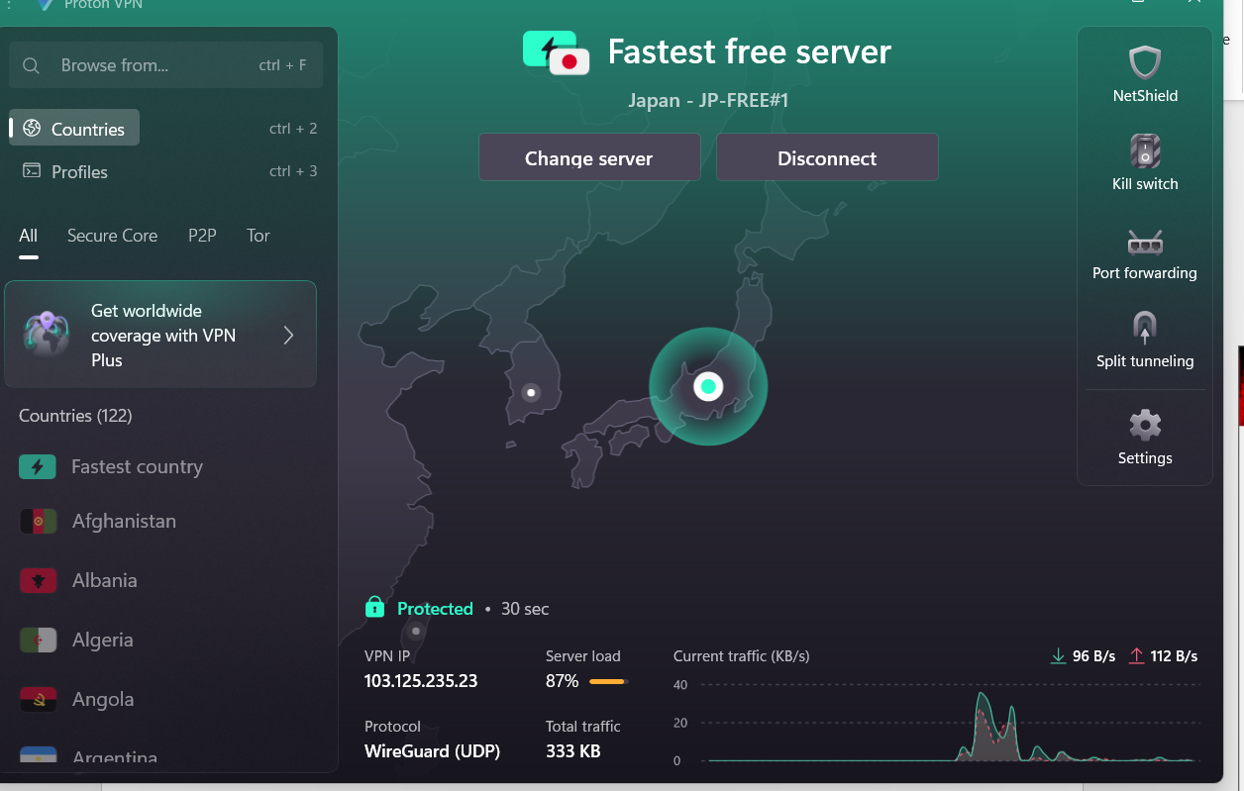

4.Verify your IP address has changed (use whatismyipaddress.com).

5.Browse a website to confirm traffic is encrypted.

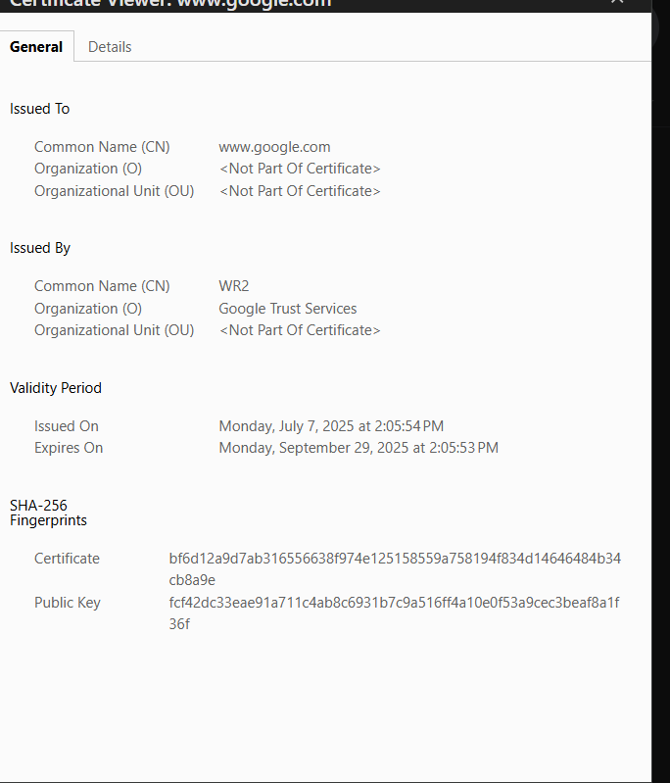

6.Disconnect VPN and compare browsing speed and IP.

7.Research VPN encryption and privacy features.

VPNs primarily enhance online privacy and security by encrypting your internet traffic and masking your IP address. This prevents your internet service provider (ISP) and others from monitoring your online.

Privacy Features:

IP Address Masking

Bypassing Geo-restrictions

Public Wi-Fi Security

Anonymity

* VPN Protocols:
  + OpenVPN
  + Wire Guard
  + IKEv2/IPSec
  + L2TP/IPSec

8.Write a summary on VPN benefits and limitations.

|  |  |
| --- | --- |
| **VPN pros** | **VPN cons** |
| Helps protect your privacy from ISPs and hackers | May slow your internet speed |
| Defends you on public Wi-Fi | Can be incompatible with some devices |
| Helps you avoid price discrimination | Free VPNs may be unreliable |
| Keeps you safer online, whether you’re gaming or checking bank accounts | Good VPNs often cost money |
| Makes remote working more secure | Can affect your device’s performance |
| Lets you access your regular sports streams while traveling | Access is restricted in some regions |

**benefits of using a VPN**

1. Enhanced privacy

2. Improved security

3. Access to home content abroad

4. Greater internet freedom

5. Reduced activity-based bandwidth